|  |  |
| --- | --- |
| https://oracle.github.io/learning-library/workshops/journey4-adwc/images/obe_tag.png | **Bonus Lab 7: Create an application using oracle APEX** |

**Introduction**

During this lab you will be using APEX with your Autonomous Data Warehouse. Oracle Application Express (APEX) is a low-code development platform that enables you to build stunning, scalable, secure apps with world-class features that can be deployed anywhere.

**Objectives**

* Learn how to create an application using APEX
* Learn how to upload data with APEX

**Required Artifacts**

* The following lab requires an Oracle Public Cloud account. You may use your own cloud account, a cloud account that you obtained through a trial, or a training account whose details were given to you by an Oracle instructor.

**Building your first app**

Creating an App from a Spreadsheet.

**STEP 1: Logging In**

* Go back to the Cloud Console and open the Instances screen. Find your database, click the action menu and select **Service Console**.

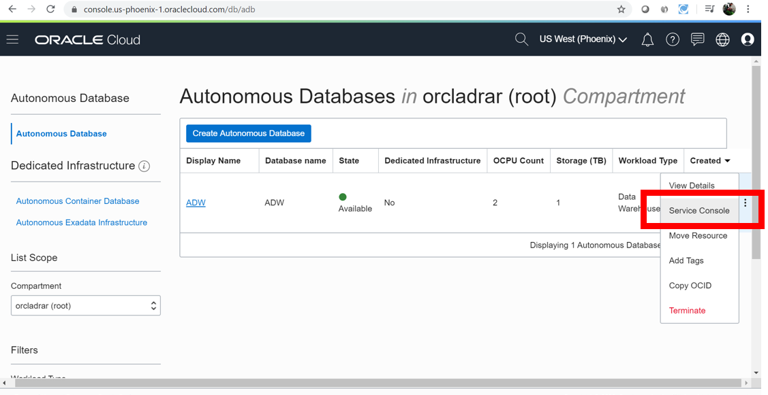

* Go to the **Development** tab and click **Oracle APEX**

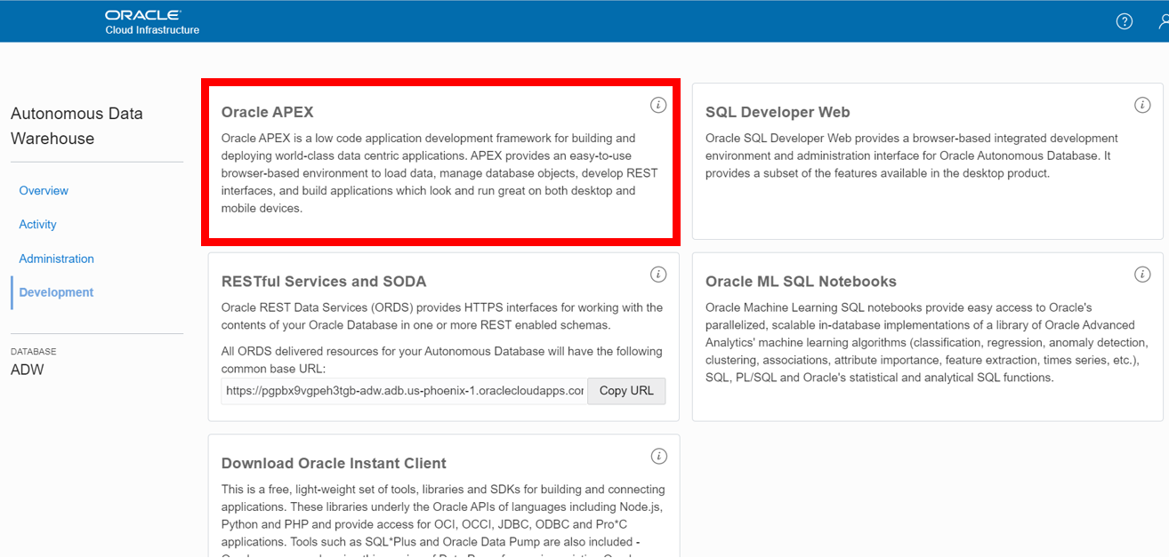

This will open a new tab within your browser that asks you for a password.

* Enter **admin’s** password you specified when provisioning your ADWC instance.

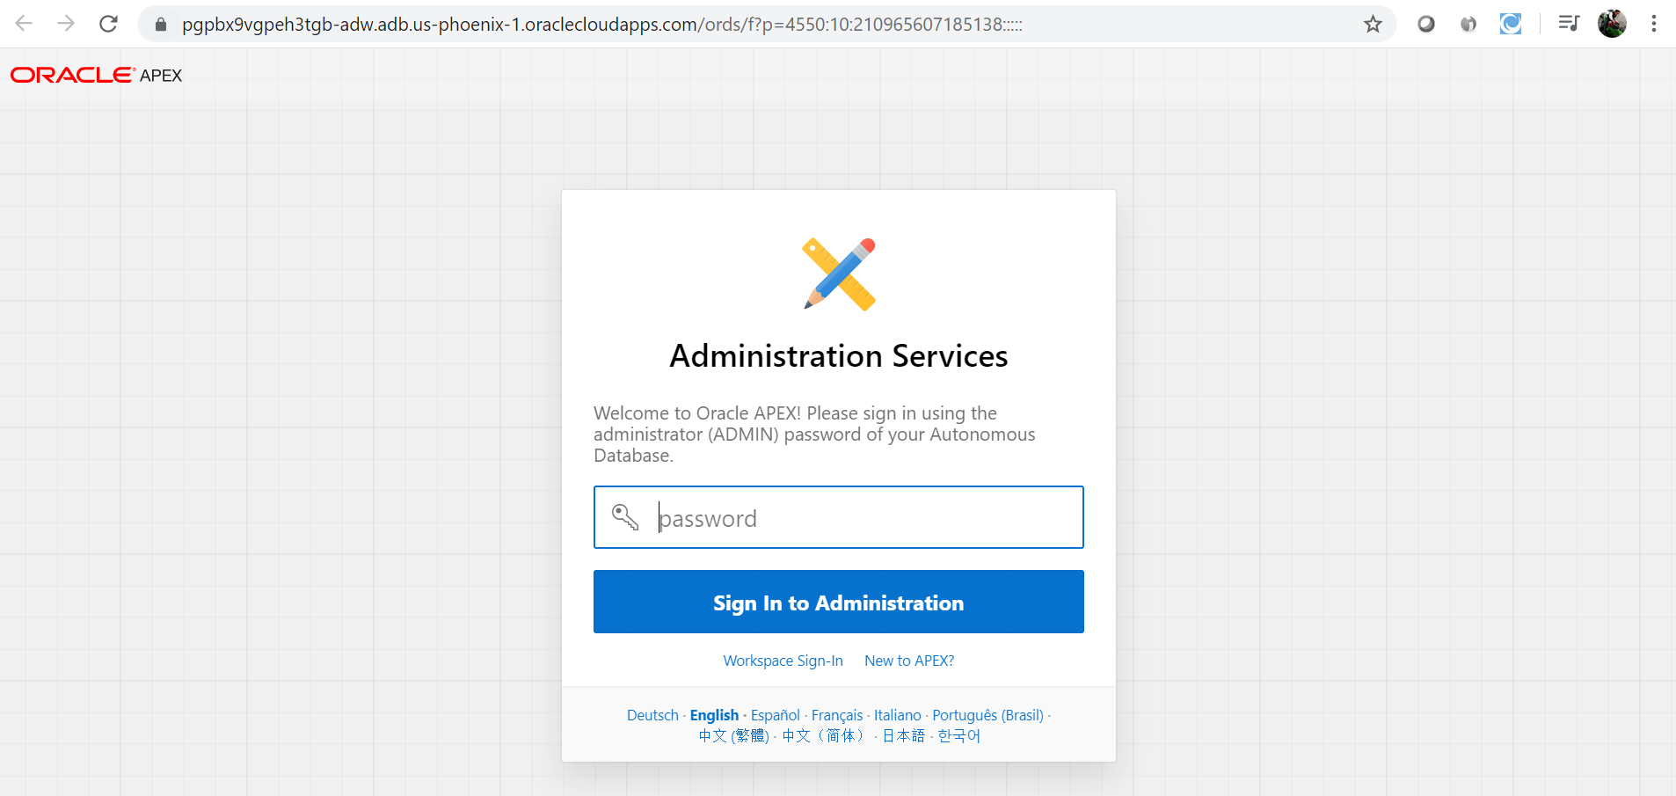

* Click **Create Workspace** button. Note that this will also create a new database user with the same name. This newly created user will be able to create the APEX application.

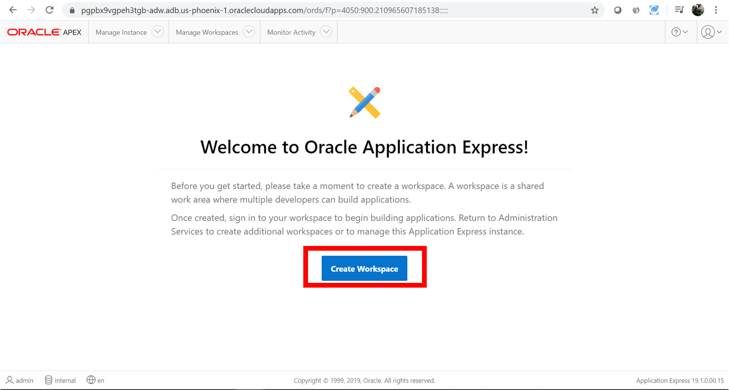

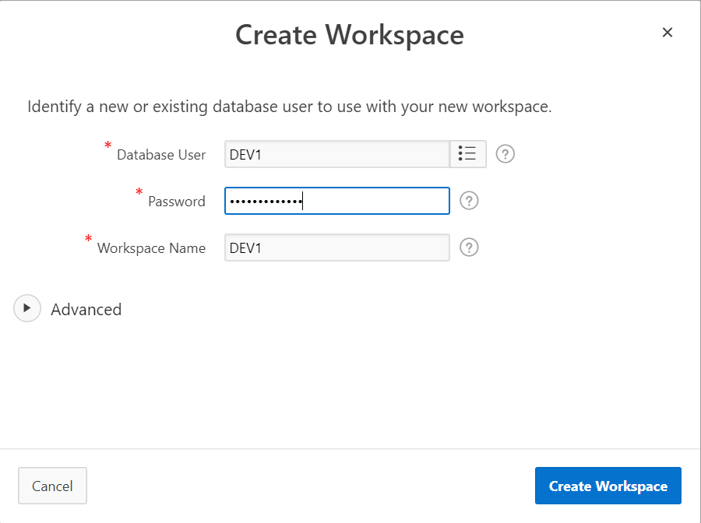

* Enter **DEV1** as the username and the password and click on Create Workspace.

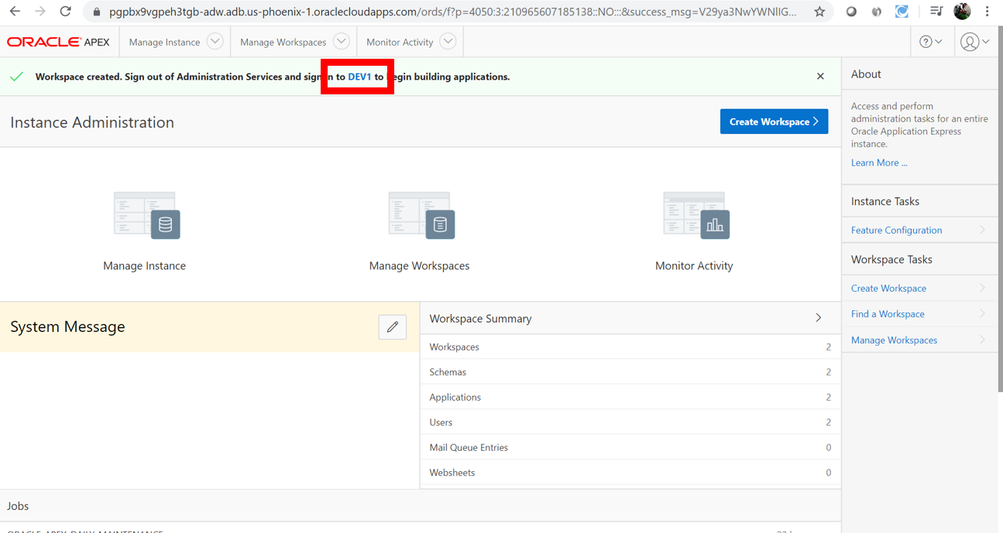

Click on DEV1 to enter to the new created workspace

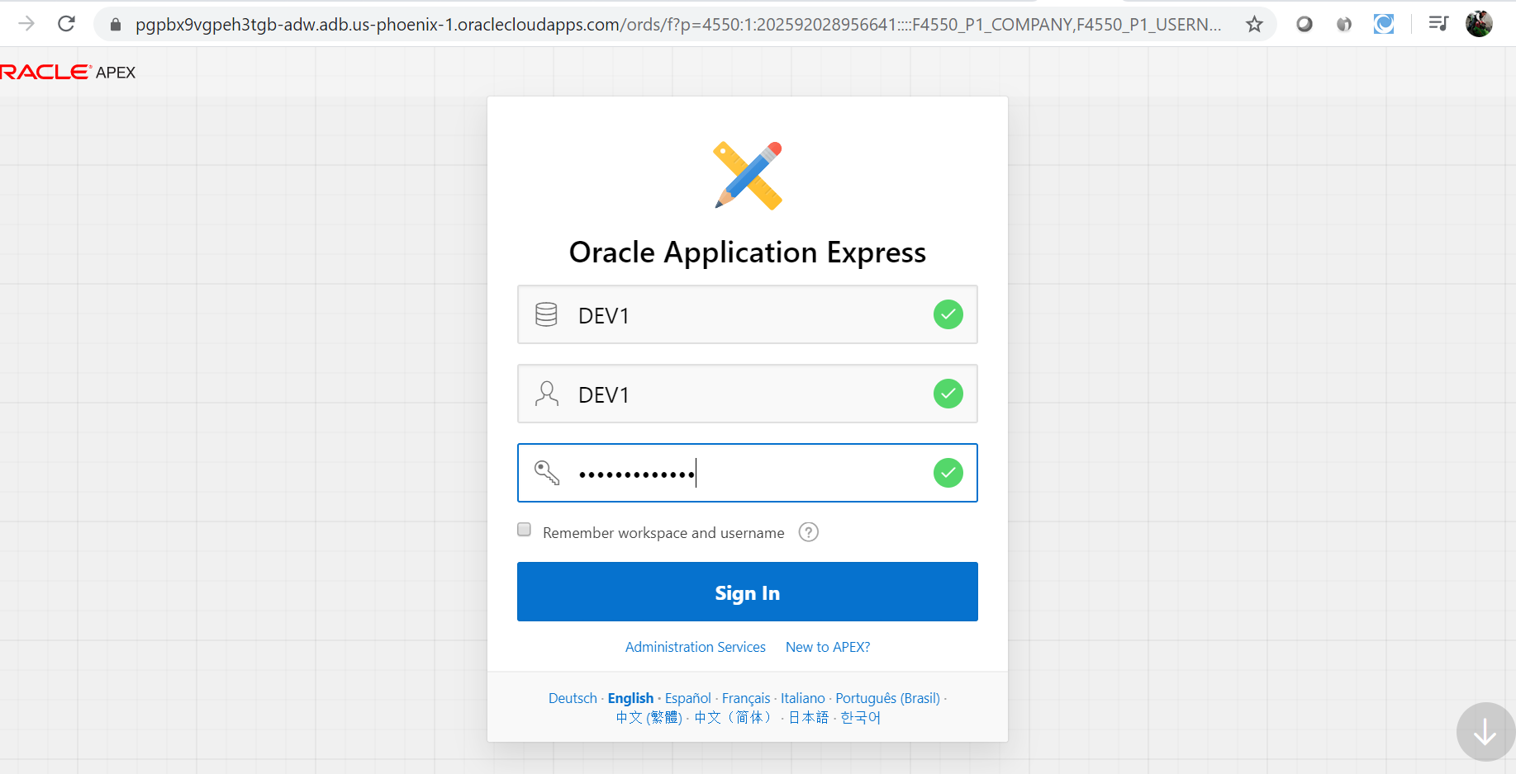

* Enter the required information for this user, **DEV1**. Click the **Sign In** button, to access the workspace.

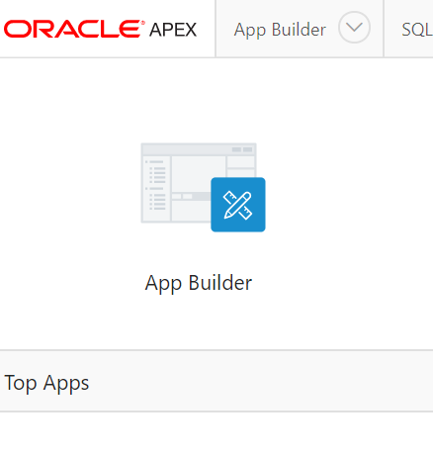

Click App Builder 🡪 Click Create a New App

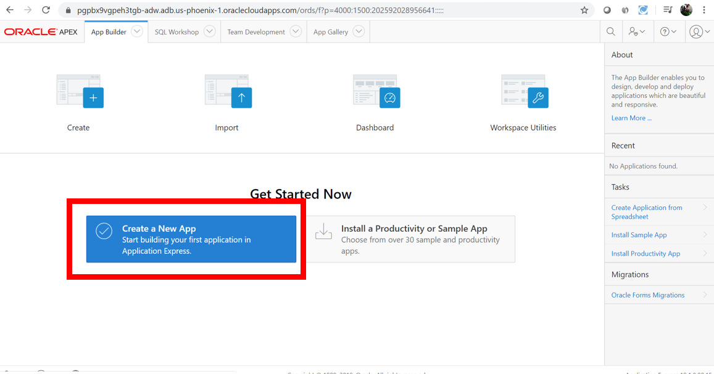

* Select From a File.

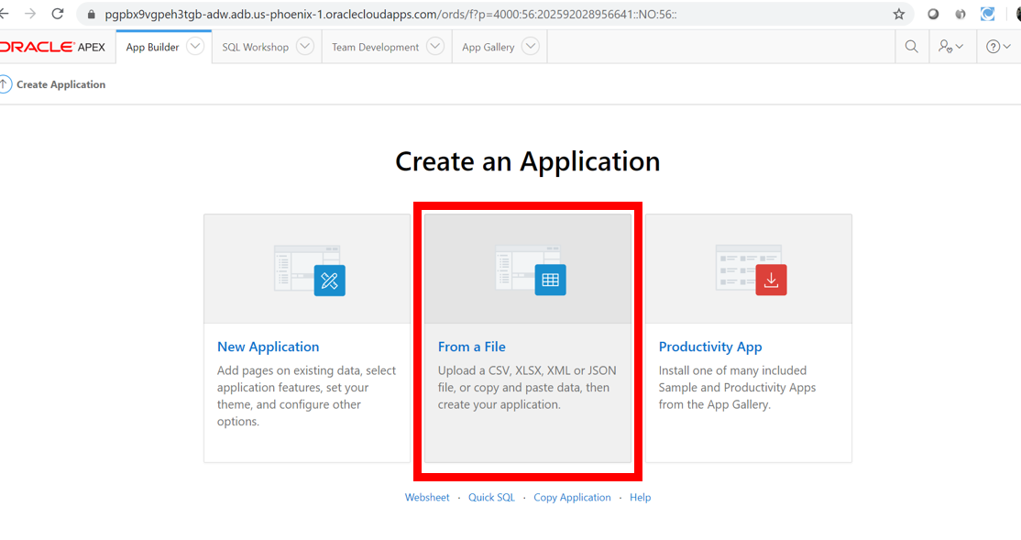

* Click Copy and Paste
* For Sample Data Set select Project and Tasks.

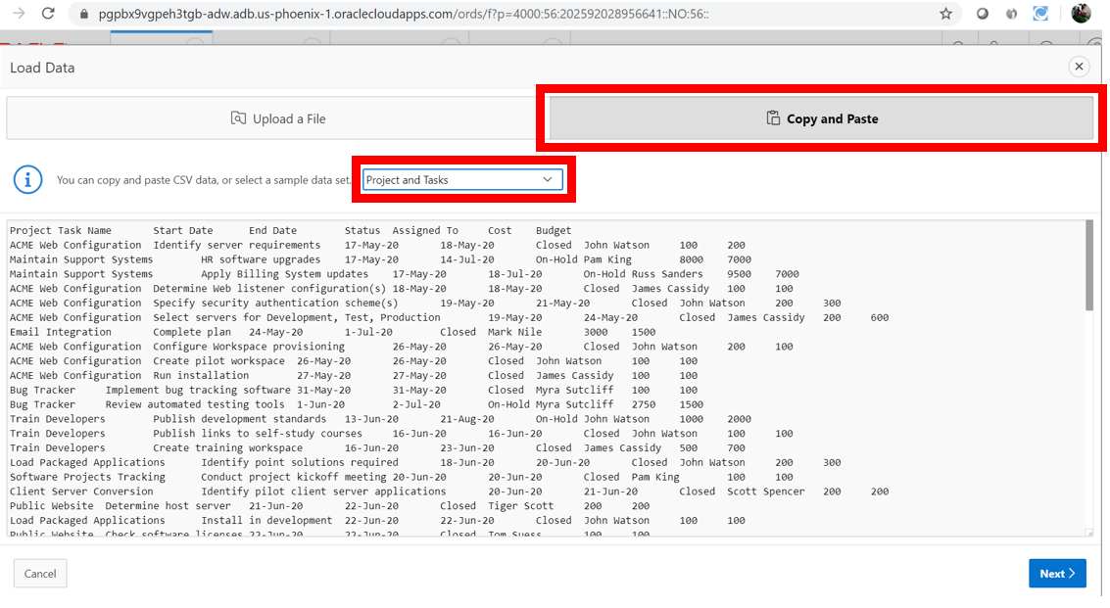

Click Next

• Enter Table Name {**SPREADSHEET**} and Click **Load Data**.

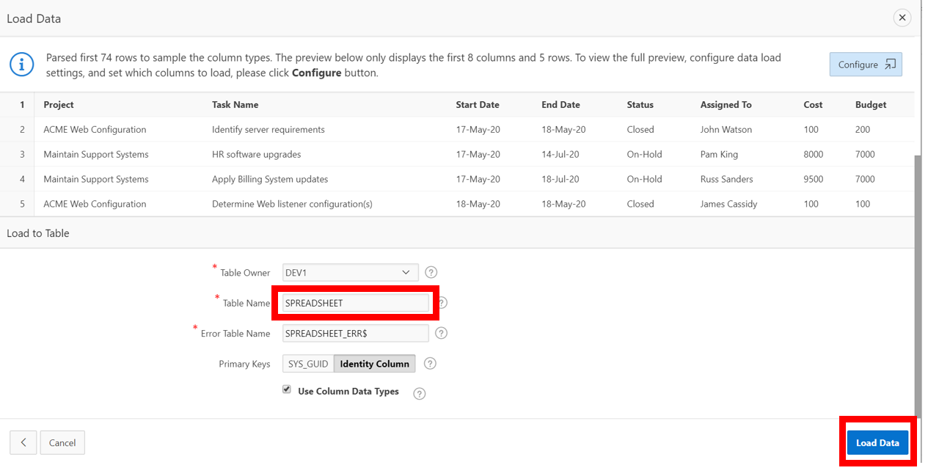

**Verifying Records Loaded.**

**• Check that 73 rows are loaded**

**• Click Continue to Create Application Wizard**

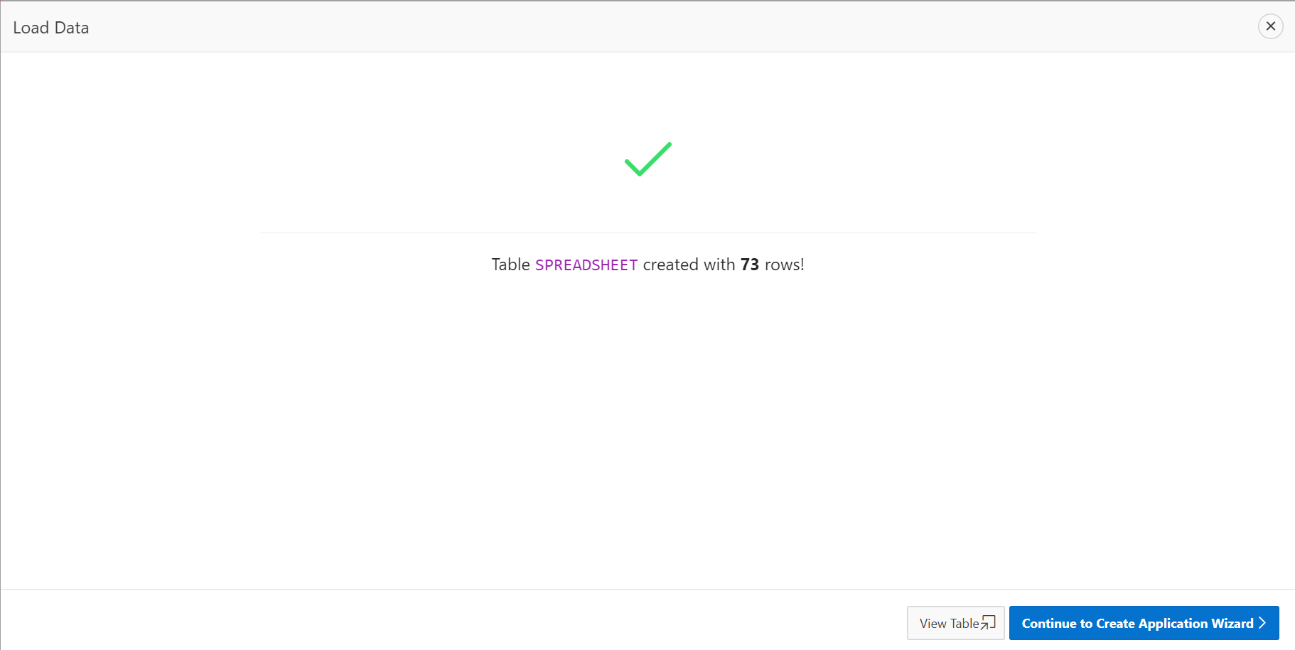

**Create an Application**

* Enter Name
* {App from a Spreadsheet}
* Next to Features,
* click Check All

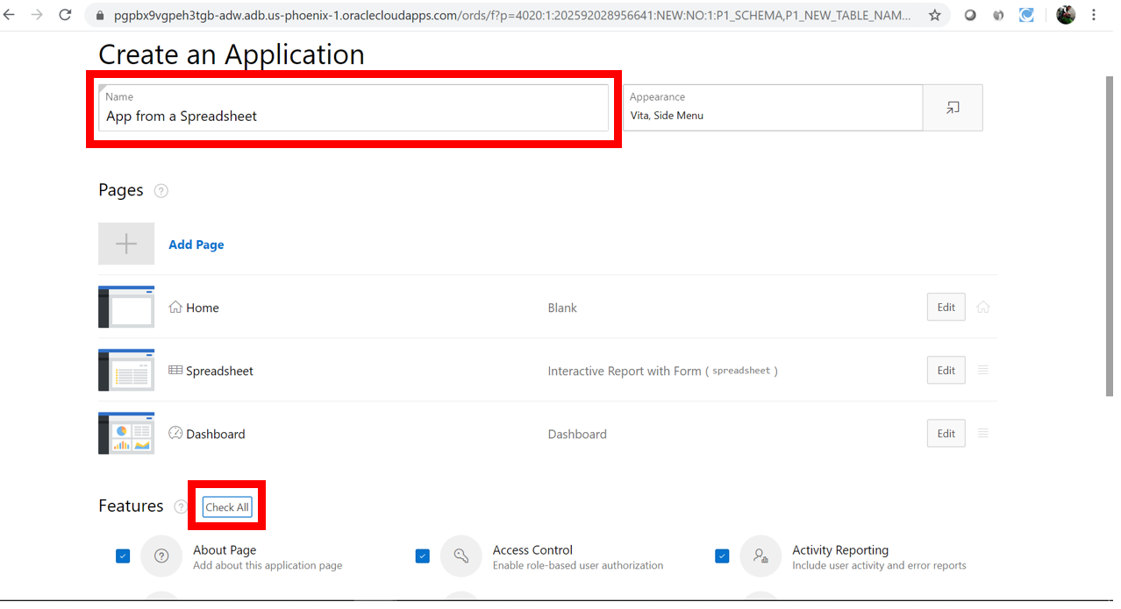

**Click Create Application**

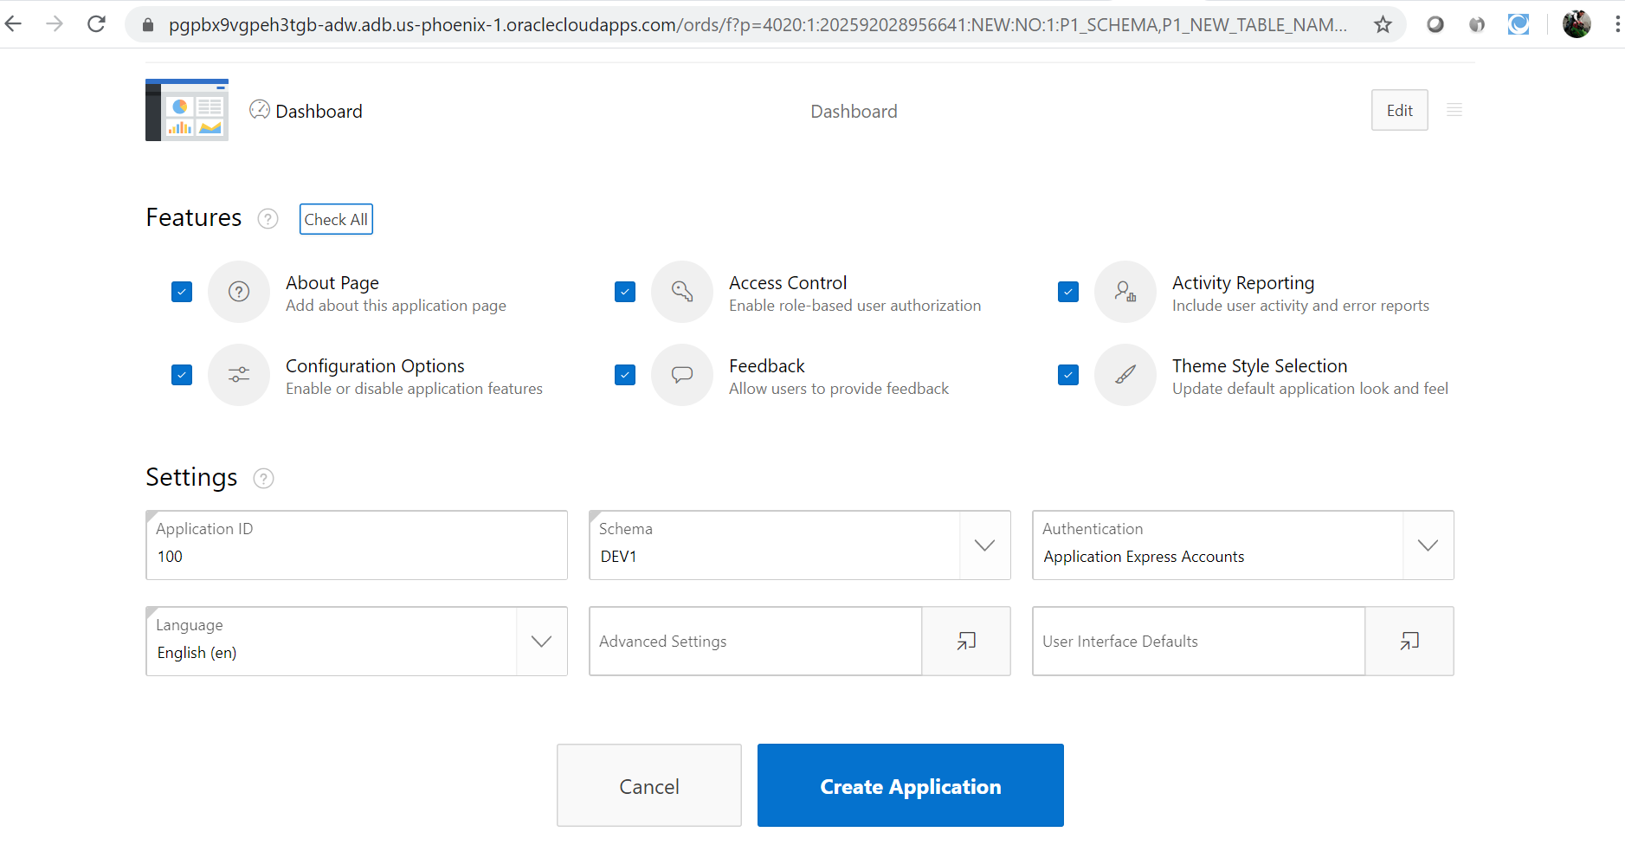

* Your new application will be displayed in Page Designer.
* Click Run Application

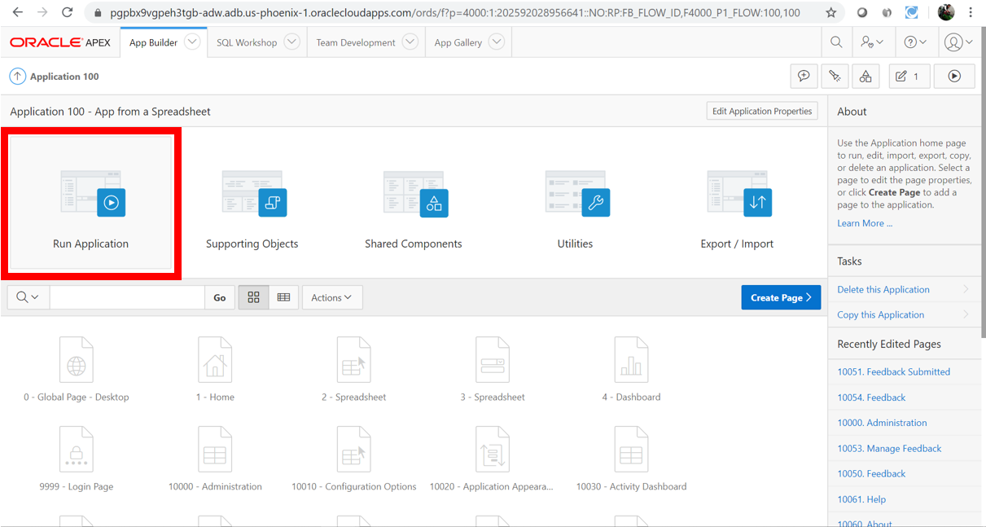

• Enter your user credentials

• Play around with your new application.

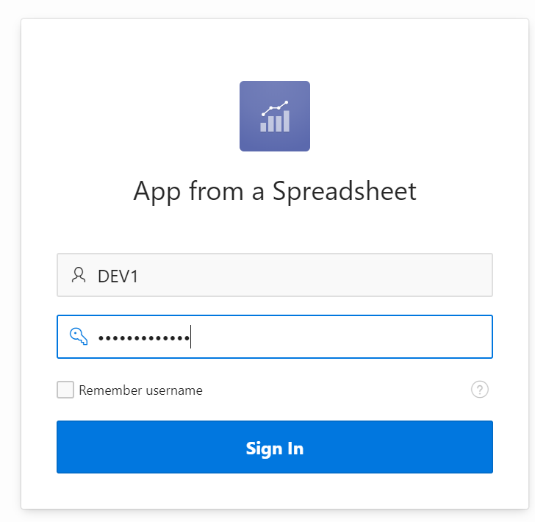

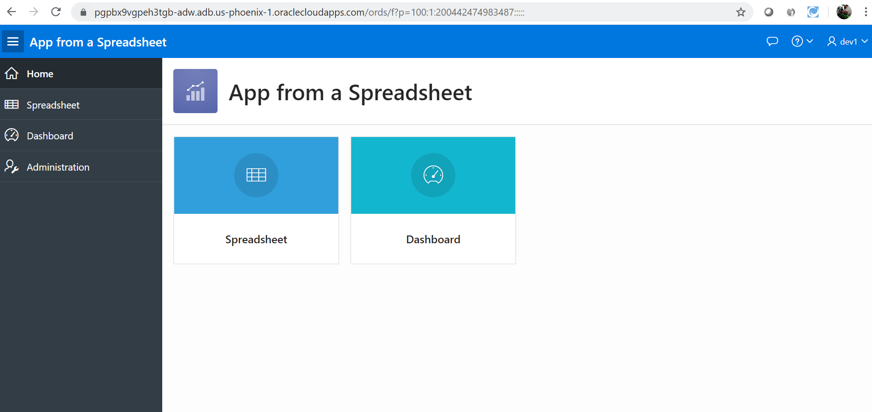

**Using the Runtime Environment**

**Improving the AppStep 1 – Sort the Interactive Report**

• Click Spreadsheet

• Click Actions, select Data, select Sort

• For 1, select Start Date; For 2, select End Date; click Apply.

|  |  |
| --- | --- |
|  |  |

**Step 2 – Add a Computation**

• Click Actions, select Data, select Compute

• Column Label enter Budget V Cost

• Format Mask select $5,234.10

• Computation Expression enter I – H

• Click Apply:

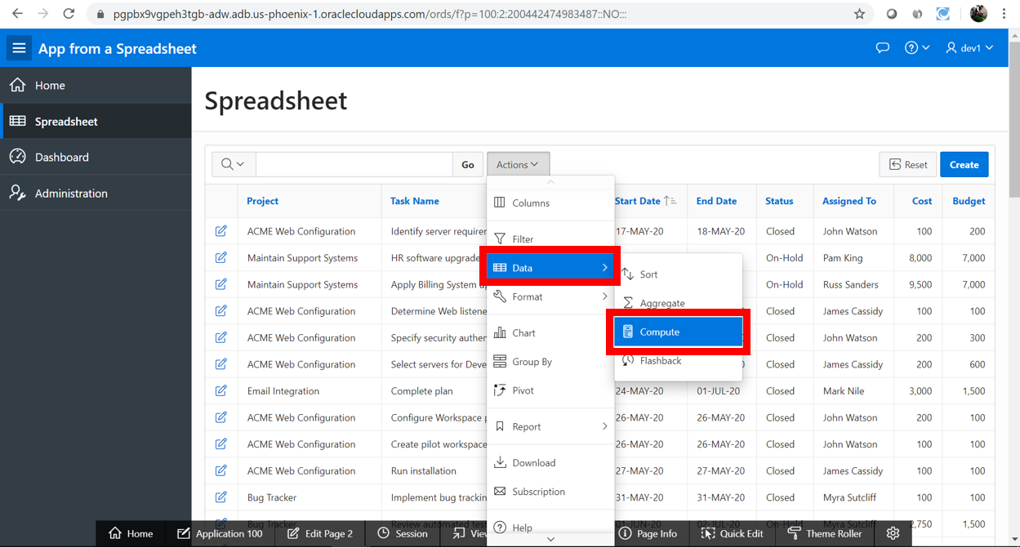

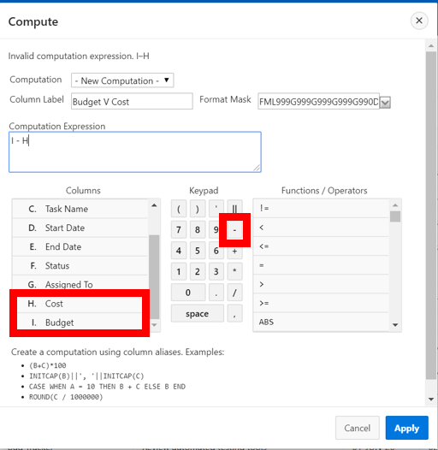

**Step 3 – Add a Chart**

• Click Actions, select Chart

• Label select Project

• Value select **Budget V Cost

• Function select Sum

• Sort select Value – Ascending

• Orientation select Horizontal

• Click Apply.

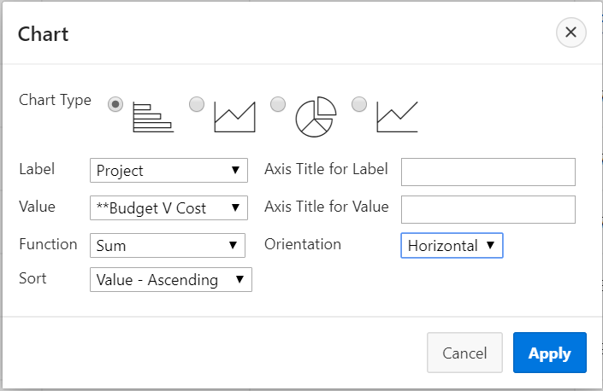

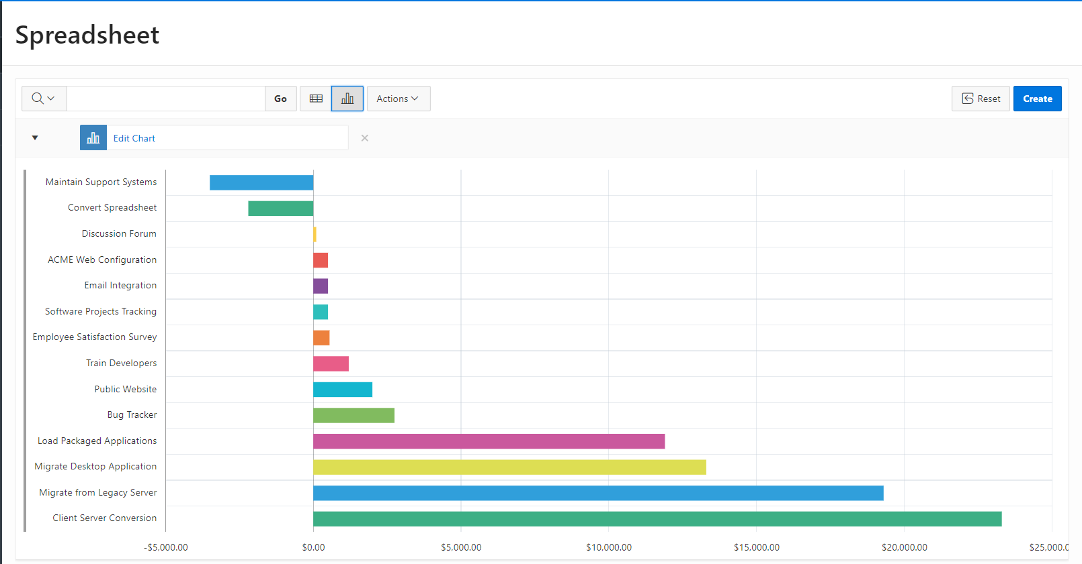

**Step 4 – Save Report**

Click Actions, select Report, select Save Report

• For Save, select As Default Report Settings

• Default Report Type, select Alternative

• Name, enter Date Review

• Click Apply

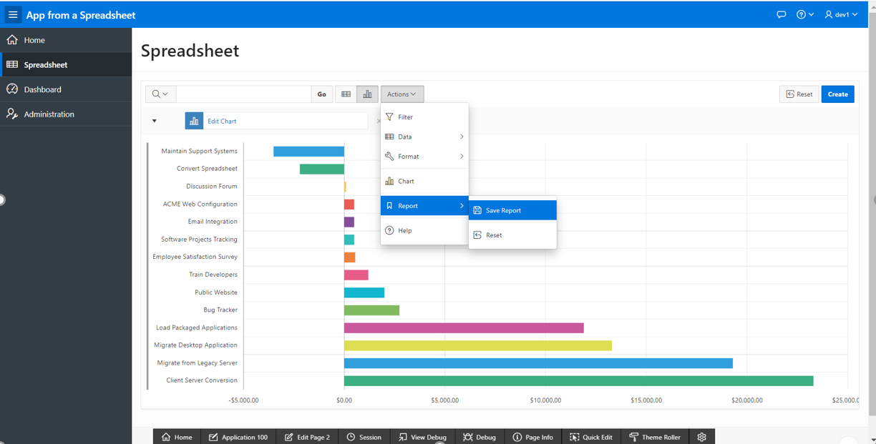

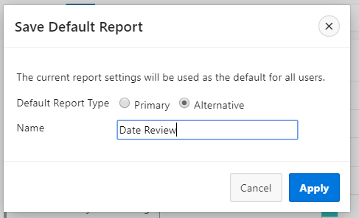

**Step 5 – Restrict the Status**

• Click reset then click the edit icon on a record

• A modal page will be displayed

• In the Developer Toolbar, click **Quick Edit**

• Over the **Status** item (until a blue outline appears) and click the mouse

• Page Designer displays with focus on the Status item

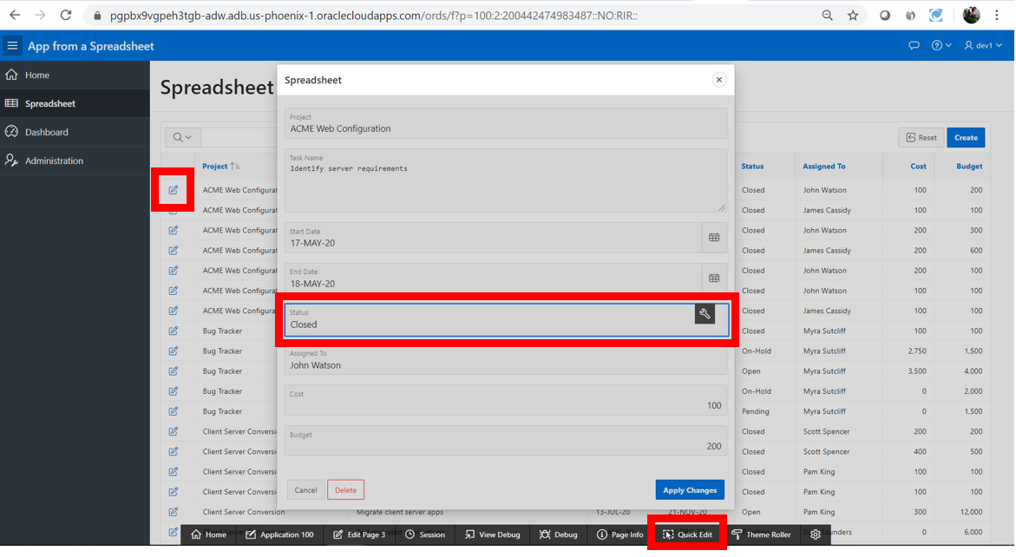

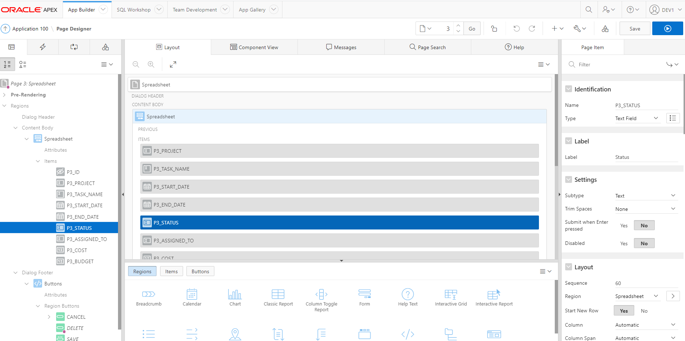

**Step 5b – Restrict the Status**

• In Page Designer, within the Property Editor (right pane),for Identification 🡪 Type 🡪 select **Select List**

• Under List of Values, for Type select **SQL Query**

• Next to SQL Query, click Code Editor 🡪 Within the Code Editor, enter the following:

select distinct status d, status r

from spreadsheet

order by 1

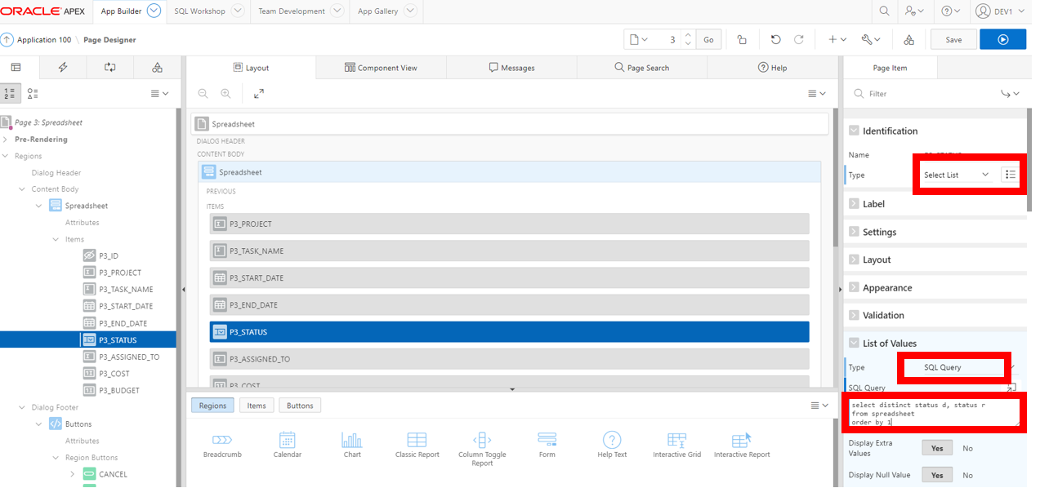

• Display Extra Values, select No

• Null Value Display, enter - Select Status -

• Click Save (In the toolbar - top right)

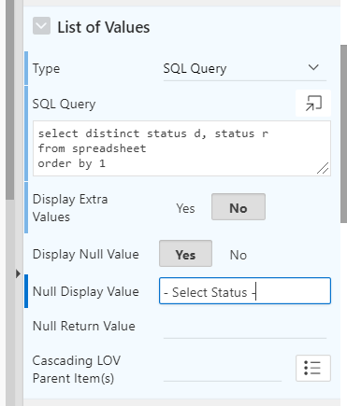

**Step 6 – Run the App**

• Navigate back

• Run Application – Select Spreadsheet

• Edit a record

• Click Status.

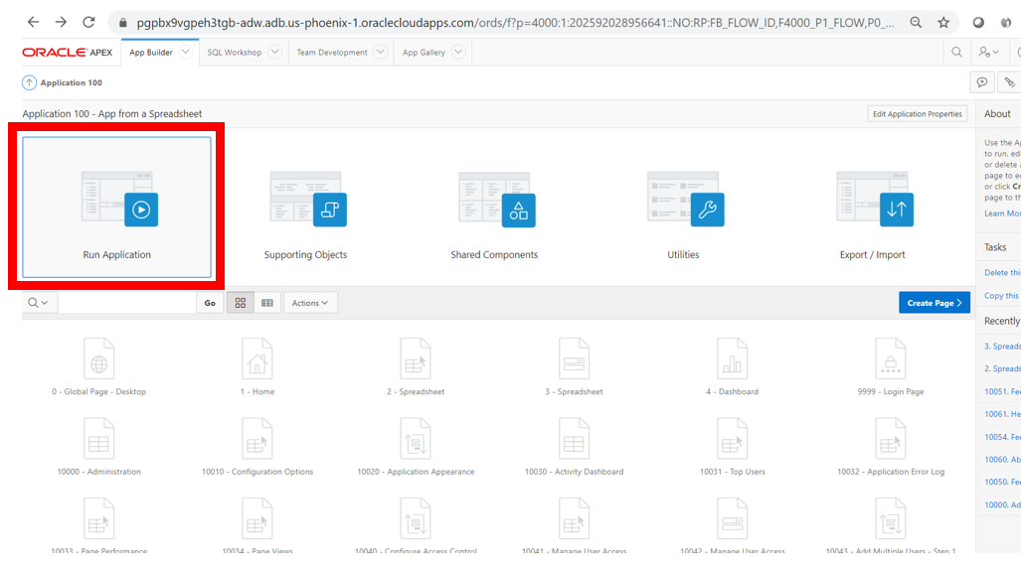

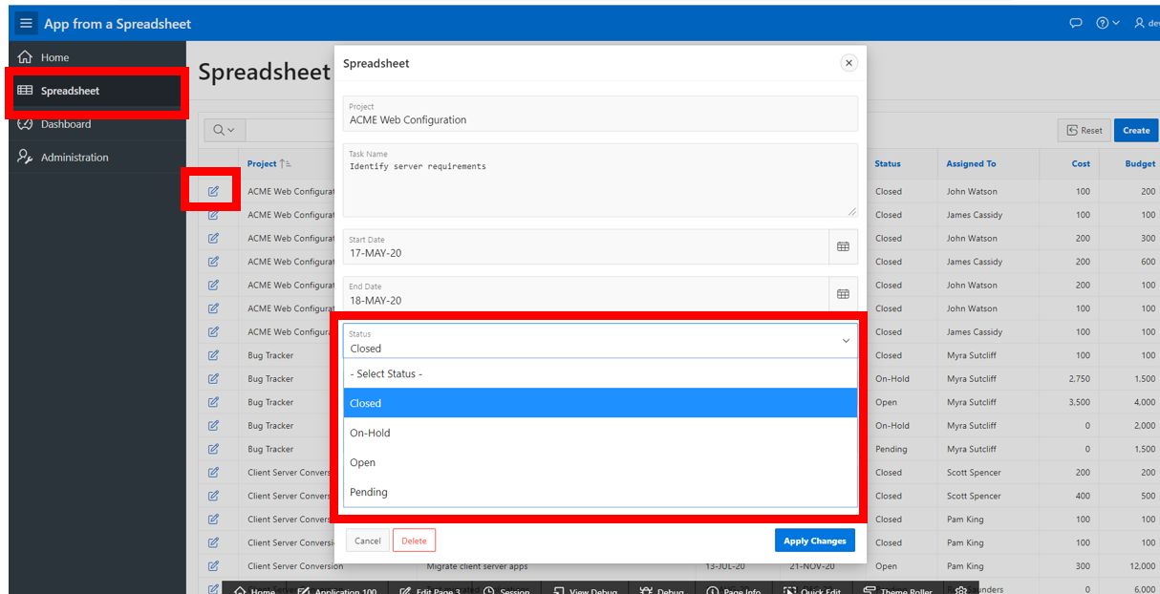

**Step 7 – Add a Calendar**

Navigate back to the development environment

• In App Builder, navigate to the App Home Page

• Click Create Page

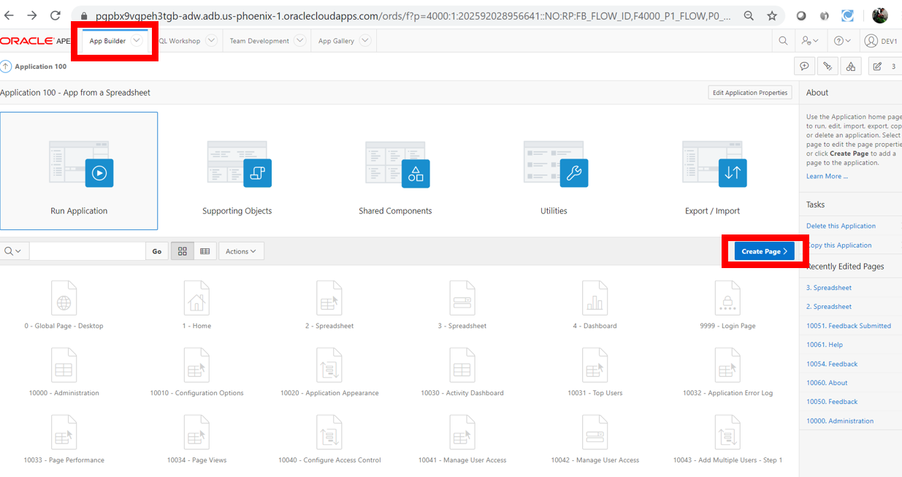

* Click Calendar

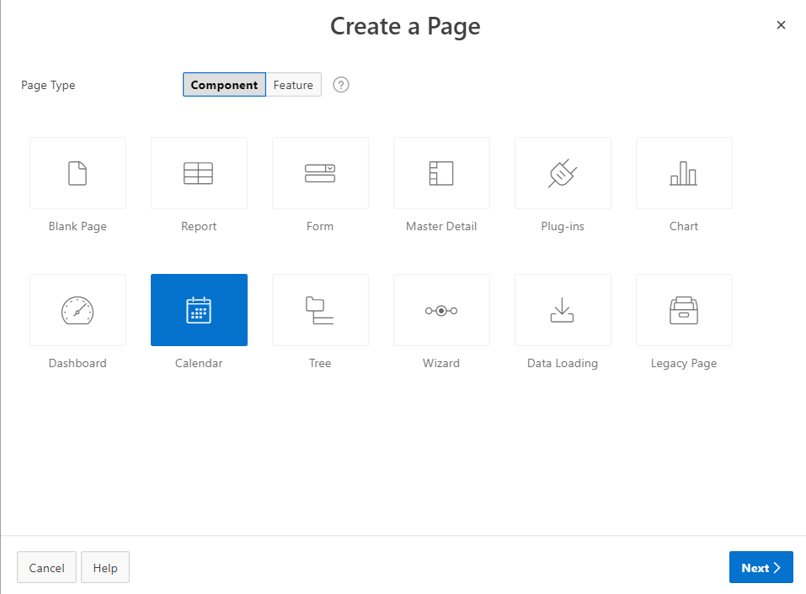

• Page Name, enter Calendar

• Breadcrumb, select Breadcrumb

• Click Next

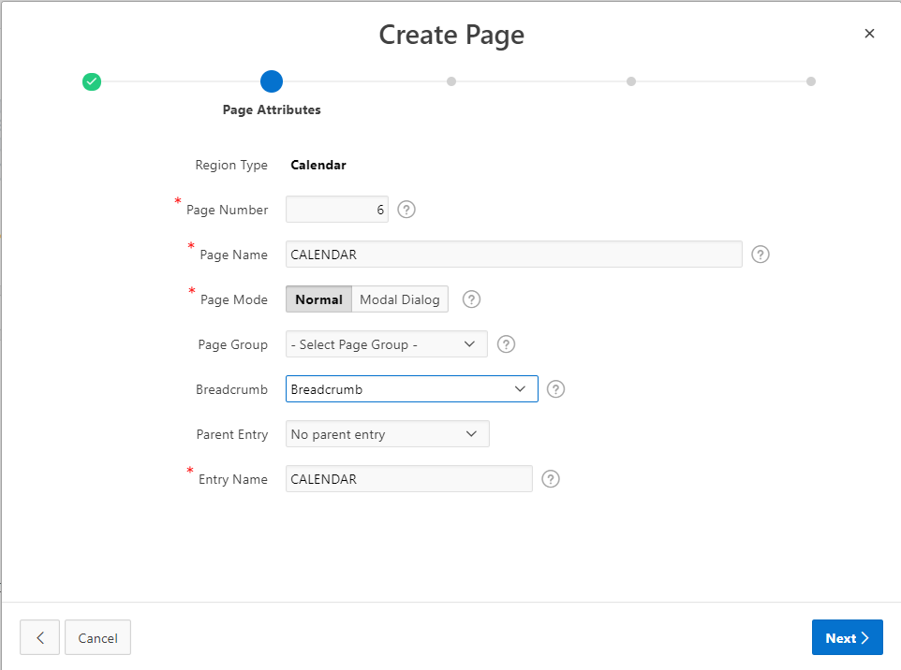

Navigation Preference, click Create a new navigation menu entry

• Click Next

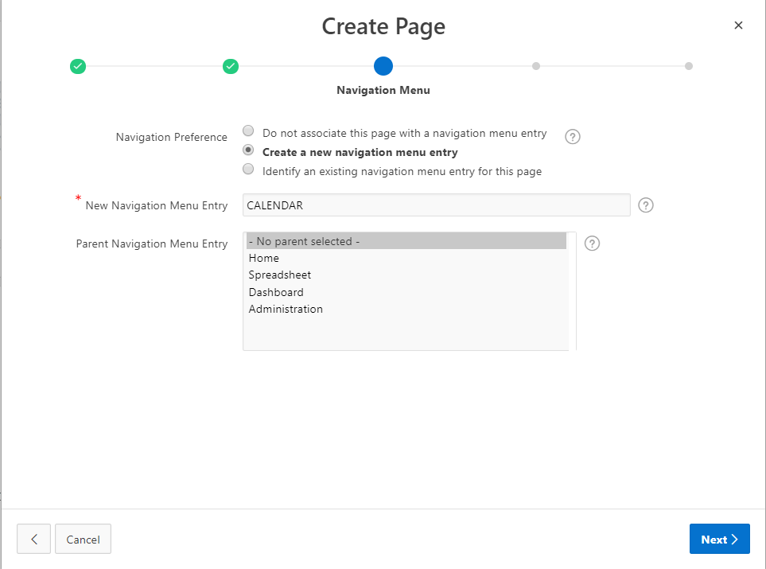

• Table / View Name, select SPREADSHEET (table)

• Click Next

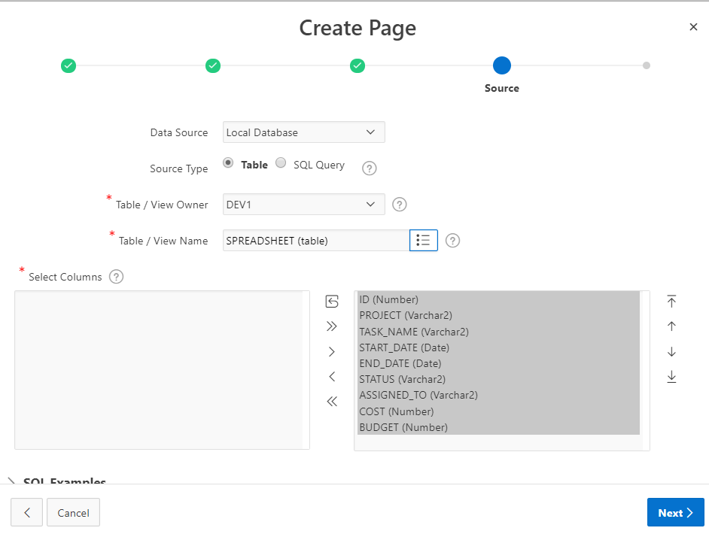

• Display Column, select TASK_NAME

• End Date Column, select END_DATE

• Click Create

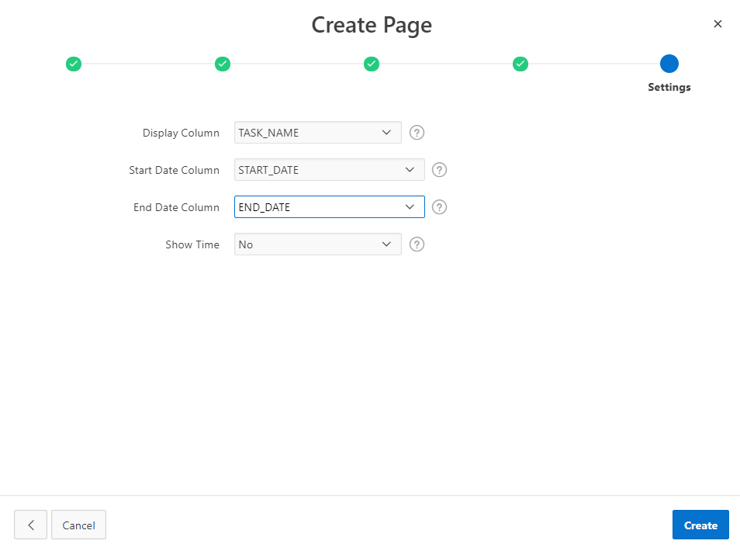

**Step 8 – Link the Calendar to the Update Form**

• In the Rendering tab, under Calendar, click Attributes

• In the Property Editor (right pane), click View / Edit Link

• Page, select 3

• Set Items – Name, select P3_ID; Value, select &ID

• Clear Cache, enter 3

• Click OK

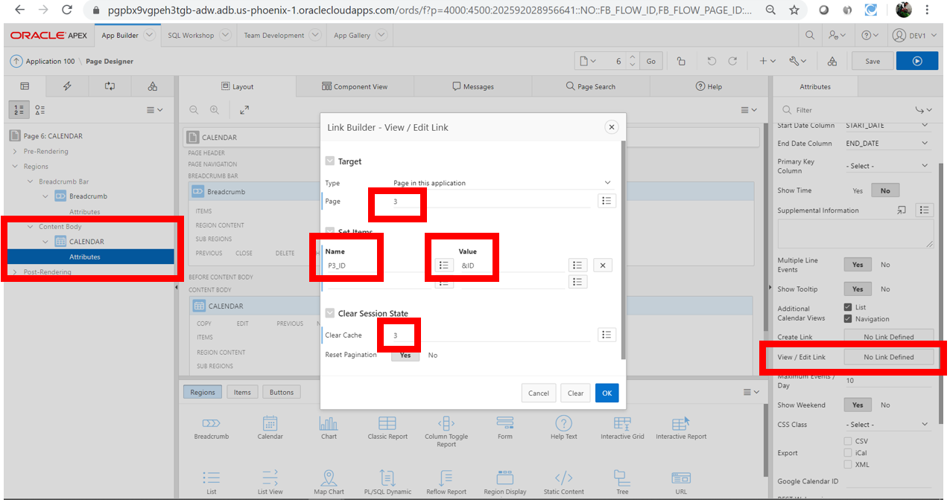

Click Save and Run

Note:

You may need to navigate to the month of May to see calendar entries.

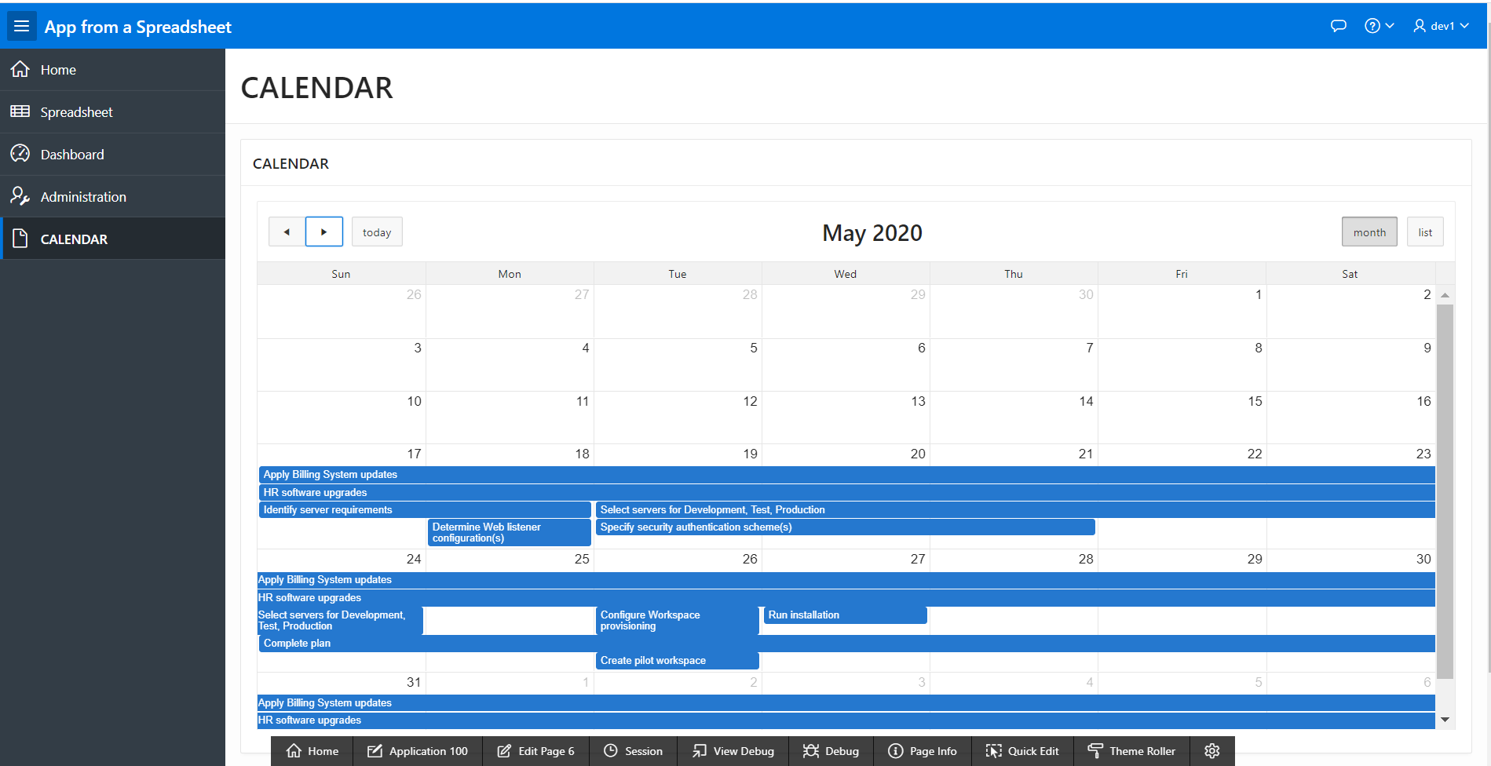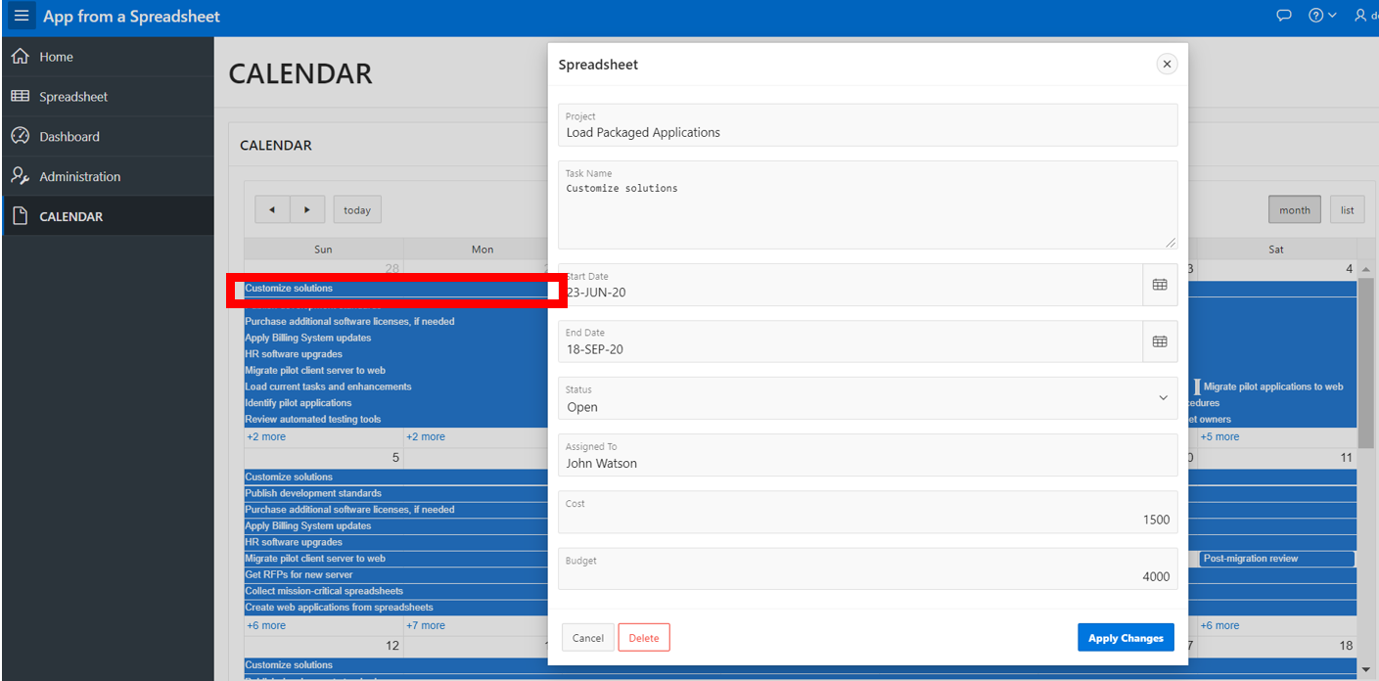

|  |  |
| --- | --- |
| [https://oracle.github.io/learning-library/workshops/journey4-adwc/images/obe_tag.png](https://oracle.github.io/learning-library/workshops/journey4-adwc/?page=LabGuide8.md) | **Great Work - All Done!**  **You are ready to move on to the next lab. You may now close this tab.** |